Application & Deployment

1. Open the following github repository <https://github.com/ZeroToHero-2017/JavaDocs/tree/master/Servlets/Day1> and copy the content to your forked github repository.
2. Go to the file location where you have copied the sources and open the project from the Code/servlet-app folder.
3. Complete TODO lines inside HelloWorldServlet.java file.
4. Complete TODO lines inside web.xml file.
5. Run maven clean install
6. Run maven tomcat7:deploy-only under the tomcat plugin

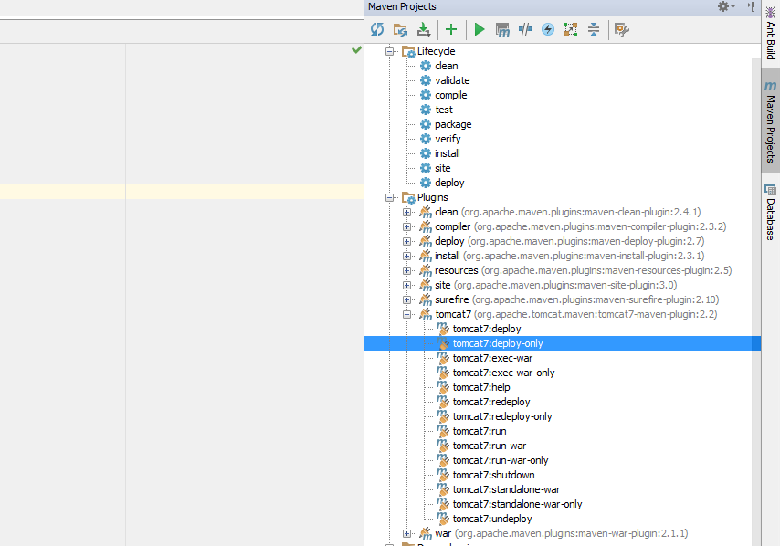

1. If you use tomcat locally, run tomcat7-run under tomcat7 plugin.

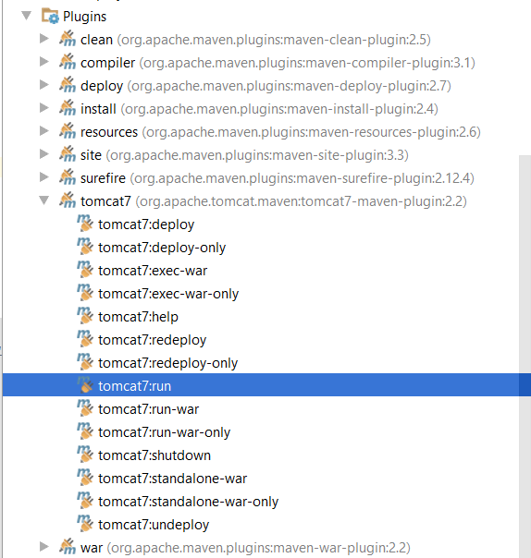

1. Open browser and insert <http://docker.local:49100/servlet-app/> URL or <http://localhost:8080/servlet-app> if you use local tomcat.

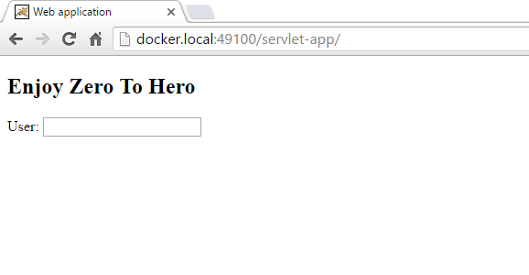

1. Insert some text into “User” input press enter and wait for server response

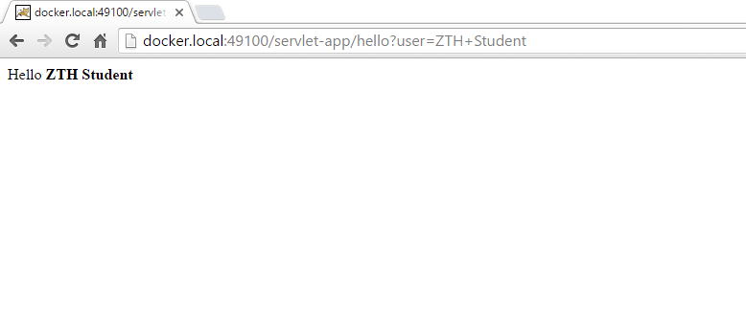

1. Complete ImportFileServlet exercise, by following the instructions from README.md file.

Happy coding! ☺